Assignment 2
Full Name : Ujjwal Biley
Internship Name : Data Analytics
Task 1 :
import numpy as np
import pandas as pd
import matplotlib.pyplot as plt
import seaborn as sns

# TASK 1
print("\n" + "=" * 60)
print("TASK 1: PYTHON BASICS & NUMPY")
print("=" * 60)

print("\n--- 1.1 Python Data Types ---")
integer_value = 25
float_value = 3.14
string_value = "Data Analytics"
boolean_value = True
list_value = [10, 20, 30]
tuple_value = (1, 2, 3)
dictionary_value = {"name": "Aarav", "age": 28}

print("Integer:", integer_value, type(integer_value))
print("Float:", float_value, type(float_value))
print("String:", string_value, type(string_value))
print("Boolean:", boolean_value, type(boolean_value))
print("List:", list_value, type(list_value))
print("Tuple:", tuple_value, type(tuple_value))
print("Dictionary:", dictionary_value, type(dictionary_value))

print("\n--- Arithmetic Operators ---")
a = 10
b = 3

print("Addition:", a + b)
print("Subtraction:", a - b)
print("Multiplication:", a * b)
print("Division:", a / b)
print("Modulus:", a % b)
print("Power:", a ** b)
print("Floor Division:", a // b)

print("\n--- Comparison Operators ---")

print("a == b:", a == b)
print("a > b:", a > b)
print("a < b:", a < b)

print("\n--- Logical Operators ---")
x = True
y = False

print("x and y:", x and y)
print("x or y:", x or y)

print("\n--- 1.2 NumPy Operations ---")
sales = np.array([
125, 138, 142, 155, 168, 180,
195, 210, 225, 240, 258, 275
])

print("Sales Array:", sales)
print("Shape:", sales.shape)
print("Size:", sales.size)
print("Dtype:", sales.dtype)

print("Sum:", sales.sum())
print("Mean:", sales.mean())
print("Maximum:", sales.max())
print("Minimum:", sales.min())
print("Standard Deviation:", sales.std())

reshaped_sales = sales.reshape(4, 3)

print("\nReshaped Array (4 x 3):")
print(reshaped_sales)

high_sales_indices = np.where(sales > 200)

print("\nIndices where sales > 200:")
print(high_sales_indices)

growth = np.diff(sales)

print("\nMonth-over-month growth:")
print(growth)

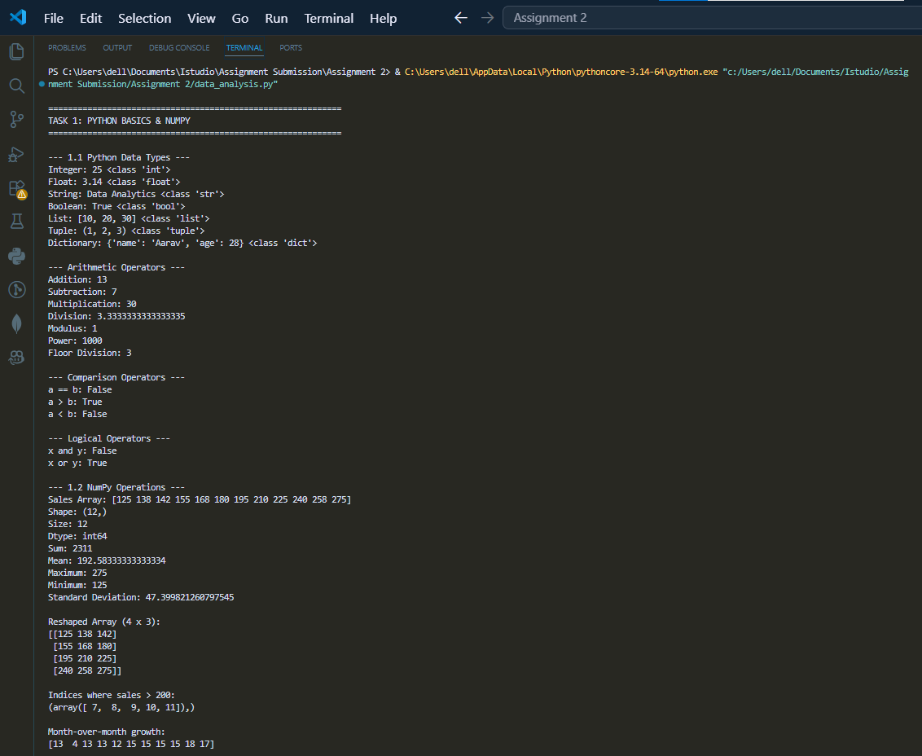

Task 2 :

# TASK 2:
print("\n" + "=" * 60)
print("TASK 2: PANDAS - DATA LOADING, CLEANING & MERGING")
print("=" * 60)

customers_data = {
"cust_id": [
"C01", "C02", "C03", "C04",
"C05", "C06", "C07", "C08"
],

"name": [
"Aarav", "Bhavya", "Chirag", "Diya",
"Eshan", "Farah", "Gaurav", "Hina"
],

"city": [
"Mumbai", "Delhi", "Bangalore", "Mumbai",
"Pune", "Delhi", "Bangalore", "Mumbai"
],

"age": [
28, 32, 26, np.nan,
30, 29, 40, 27
],

"gender": [
"M", "F", "M", "F",
"M", "F", "M", np.nan
]
}

customers_df = pd.DataFrame(customers_data)

purchases_data = {
"purchase_id": [
"P101", "P102", "P103", "P104", "P105",
"P106", "P107", "P108", "P109", "P110"
],

"cust_id": [
"C01", "C02", "C03", "C01", "C05",
"C02", "C06", "C07", "C03", "C05"
],

"product": [
"Laptop", "Saree", "Smartphone", "Tablet",
"Headphones", "Watch", "T-shirt",
"Backpack", "Mouse", "Charger"
],

"amount": [
55000, 4500, 32000, 18000, 1500,
3500, 499, 1800, 899, 650
],

"purchase_date": [
"2025-02-03", "2025-02-05", "2025-02-09",
"2025-02-11", "2025-02-12", "2025-02-14",
"2025-02-18", "2025-02-20", "2025-02-22",
"2025-02-26"
]
}

purchases_df = pd.DataFrame(purchases_data)

print("\n--- Customers DataFrame ---")
print(customers_df.head())

print("\nCustomers Shape:")
print(customers_df.shape)

print("\nCustomers Info:")
customers_df.info()

print("\n--- Purchases DataFrame ---")
print(purchases_df.head())

print("\nPurchases Shape:")
print(purchases_df.shape)

print("\nPurchases Info:")
purchases_df.info()

print("\n--- Missing Values Before Cleaning ---")
print(customers_df.isnull().sum())

customers_df["age"] = customers_df["age"].fillna(
customers_df["age"].mean()
)

customers_df["gender"] = customers_df["gender"].fillna("Unknown")

customers_df["age"] = customers_df["age"].astype(int)

print("\n--- Customers After Cleaning ---")
print(customers_df)

print("\nMissing Values After Cleaning:")
print(customers_df.isnull().sum())

purchases_df["purchase_date"] = pd.to_datetime(
purchases_df["purchase_date"]
)

merged_df = pd.merge(
customers_df,
purchases_df,
on="cust_id",
how="inner"
)

print("\n--- Merged DataFrame ---")
print(merged_df.head())

print("\nMerged Shape:")
print(merged_df.shape)

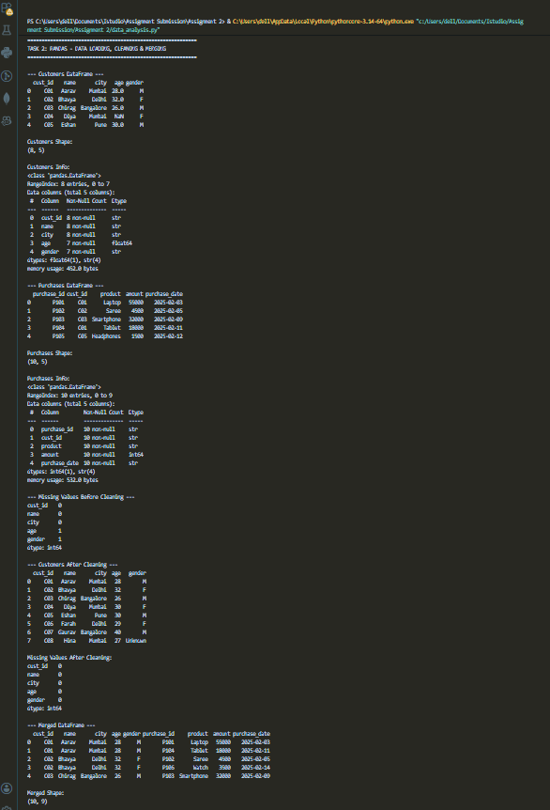

Task 3 :

# TASK 3:
print("\n" + "=" * 60)
print("TASK 3: FILTERING, GROUPING, AGGREGATION & VISUALIZATION")
print("=" * 60)

print("\n--- Purchases from Mumbai ---")

mumbai_purchases = merged_df[
merged_df["city"] == "Mumbai"
]

print(mumbai_purchases)

print("\n--- Purchases with Amount > 5000 ---")

high_amount_purchases = merged_df[
merged_df["amount"] > 5000
]

print(high_amount_purchases)

print("\n--- Male Customers Who Made Purchases ---")

male_customers = merged_df[
merged_df["gender"] == "M"
]

print(male_customers)

print("\n--- Total Purchase Amount Per City ---")

city_totals = merged_df.groupby("city")["amount"].sum()

print(city_totals)

print("\n--- Average Purchase Amount Per Gender ---")

gender_average = merged_df.groupby("gender")["amount"].mean()

print(gender_average)

print("\n--- Number of Purchases Per Customer ---")

purchase_count = merged_df.groupby(
["cust_id", "name"]
).size()

print(purchase_count)

print("\n--- Most Active Customers ---")

max_purchase_count = purchase_count.max()

most_active_customers = purchase_count[
purchase_count == max_purchase_count
]

print("Most active customers:")
print(most_active_customers)

print("Number of purchases:", max_purchase_count)

print("\n--- Top 3 Customers by Total Spending ---")

top3 = (
merged_df.groupby("name")["amount"]
.sum()
.sort_values(ascending=False)
.head(3)
)

print(top3)

print("\n" + "=" * 60)
print("3.3 DATA VISUALIZATION")
print("=" * 60)

plt.figure(figsize=(7, 5))

city_totals.plot(kind="bar")

plt.title("Total Purchase Amount by City")
plt.xlabel("City")
plt.ylabel("Total Amount (INR)")
plt.xticks(rotation=0)

plt.tight_layout()
plt.savefig("Figure_1.png", dpi=300, bbox_inches="tight")
plt.show()

gender_totals = merged_df.groupby("gender")["amount"].sum()

plt.figure(figsize=(7, 5))

plt.pie(
gender_totals,
labels=gender_totals.index,
autopct="%1.1f%%",
startangle=90
)

plt.title("Share of Purchases by Gender")

plt.tight_layout()
plt.savefig("Figure_2.png", dpi=300, bbox_inches="tight")
plt.show()

top3_df = top3.reset_index()

top3_df.columns = ["name", "amount"]

plt.figure(figsize=(7, 5))

sns.barplot(
data=top3_df,
x="name",
y="amount"
)

plt.title("Top 3 Customers by Total Spending")
plt.xlabel("Customer")
plt.ylabel("Total Spending (INR)")

plt.tight_layout()
plt.savefig("Figure_3.png", dpi=300, bbox_inches="tight")
plt.show()

date_amount = (
merged_df.groupby("purchase_date")["amount"]
.sum()
.sort_index()
)

plt.figure(figsize=(9, 5))

plt.plot(
date_amount.index,
date_amount.values,
marker="o"
)

plt.title("Purchase Date vs Amount")
plt.xlabel("Purchase Date")
plt.ylabel("Amount (INR)")

plt.xticks(rotation=45)

plt.tight_layout()
plt.savefig("Figure_4.png", dpi=300, bbox_inches="tight")
plt.show()

print("\n" + "=" * 60)
print("DATA ANALYSIS SUMMARY")
print("=" * 60)

highest_revenue_city = city_totals.idxmax()
highest_revenue = city_totals.max()

average_spending = merged_df["amount"].mean()

print("Highest revenue city:", highest_revenue_city)
print("Highest revenue:", highest_revenue)

print("Most active customers:")

for customer in most_active_customers.index:
print("-", customer[1])

print("Number of purchases:", max_purchase_count)

print("Average purchase amount:", average_spending)

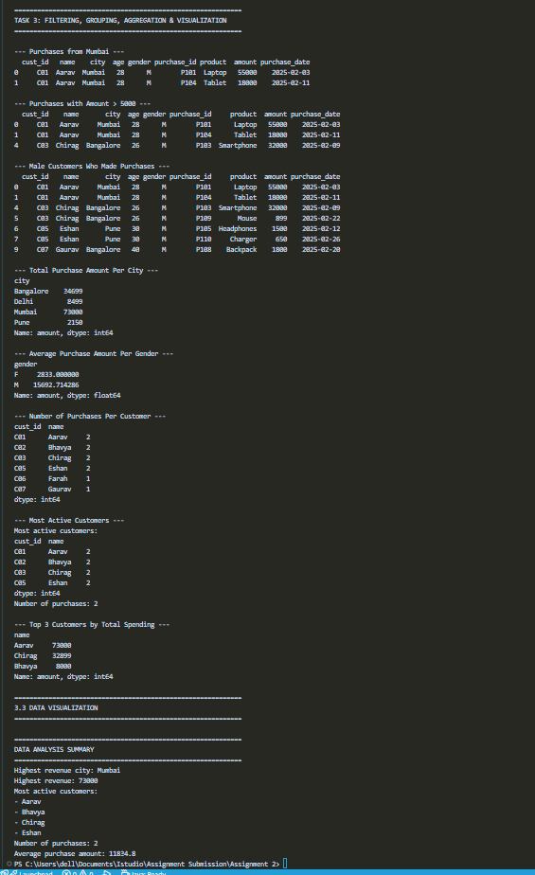

DATA ANALYSIS SUMMARY :
The analysis shows that Mumbai generated the highest total purchase revenue of INR 73,000, making it the leading city among the four cities analyzed. Bangalore recorded the second-highest revenue with INR 34,699, followed by Delhi and Pune. The analysis also shows that Aarav, Chirag, and Bhavya were among the top customers based on total spending, with Aarav spending the highest amount of INR 73,000. Male customers contributed a significantly larger share of total purchases compared to female customers. The average purchase amount across all transactions was INR 11,834.8. The purchase-date analysis shows that sales varied considerably across different dates, with the highest single-day purchase amount occurring on February 3, 2025. Overall, the analysis provides useful insights into customer spending patterns, city-wise revenue, gender-wise purchases, and sales trends.

Figure 1 :
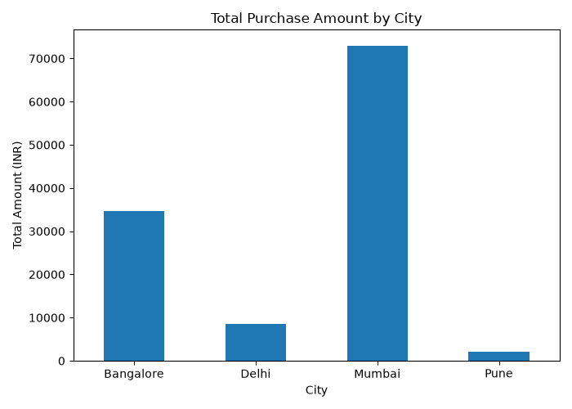

Figure 2 :

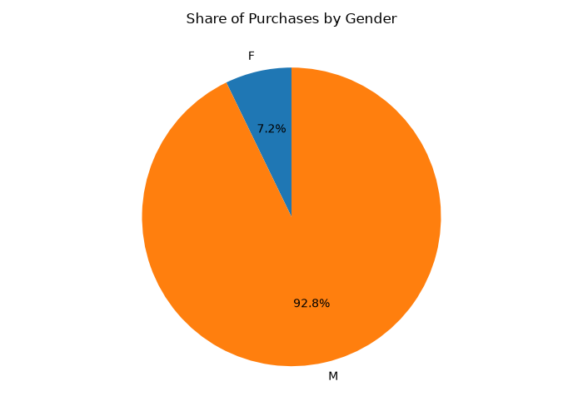

Figure 3 :

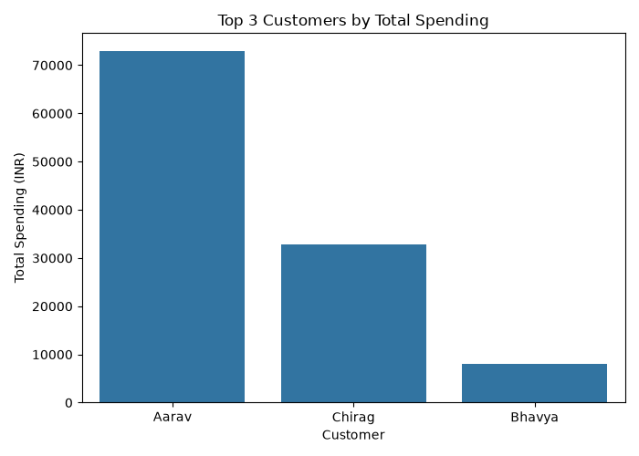

Figure 4 :

